Module 9 – Angular (v20.0)
Hands-On 1: Environment Setup, Project Structure & First Component

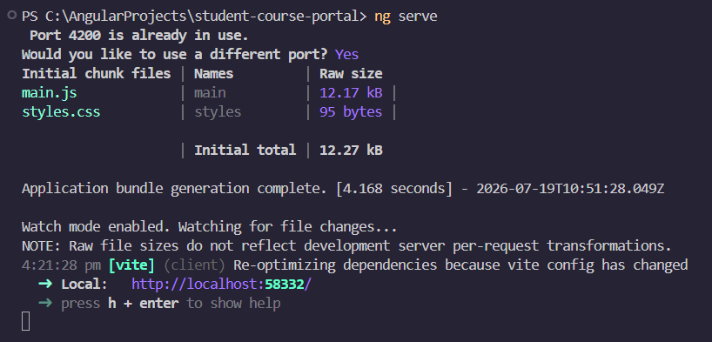
Task 1: Scaffold and Explore the Angular Project
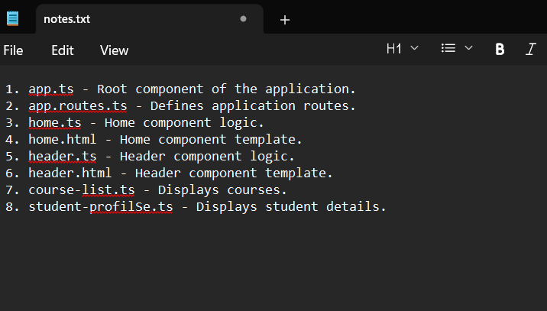
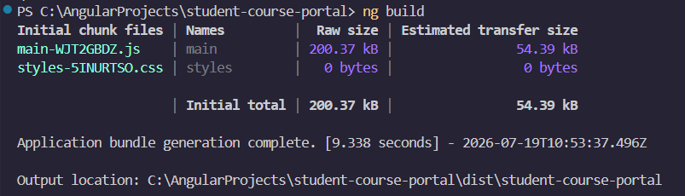

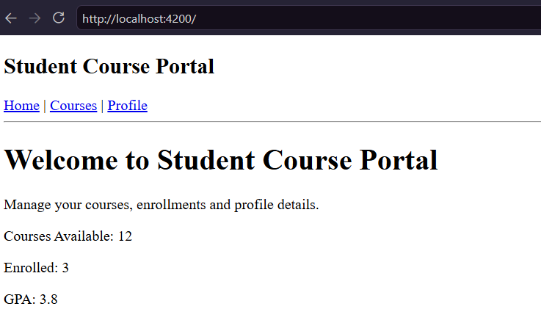
Task 2: Create and Organise Components

Hands-On 2: Data Binding, Lifecycle Hooks & Component Communication

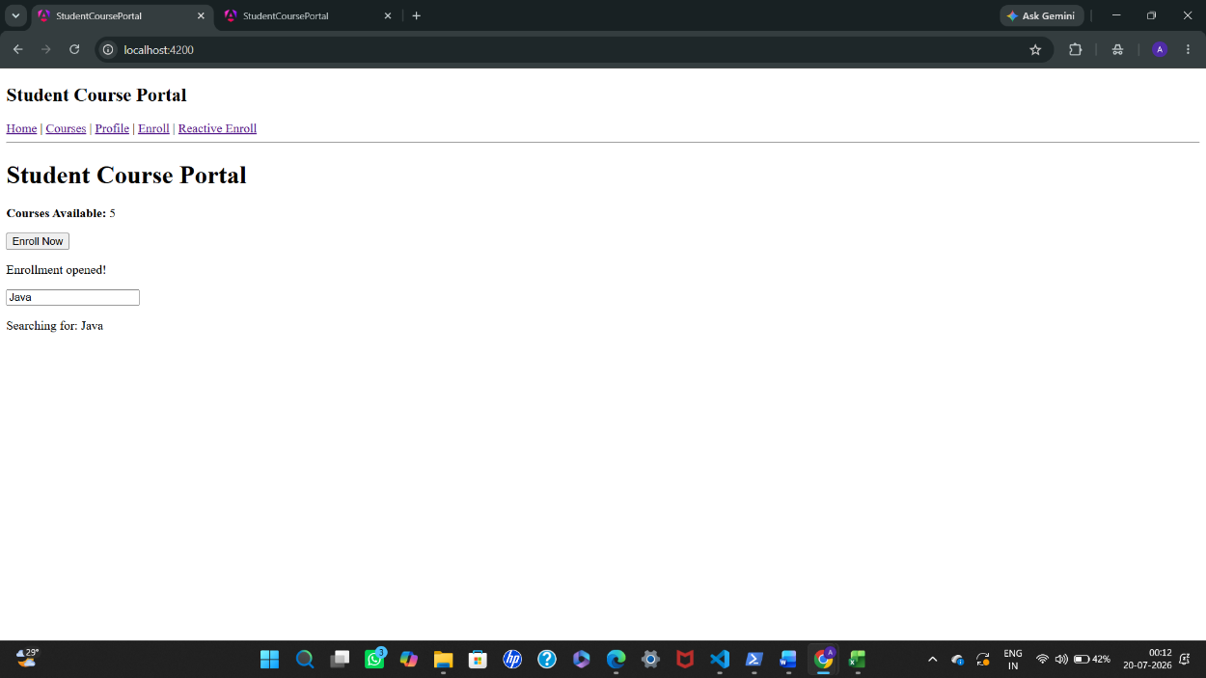
Task 1: All Four Binding Types

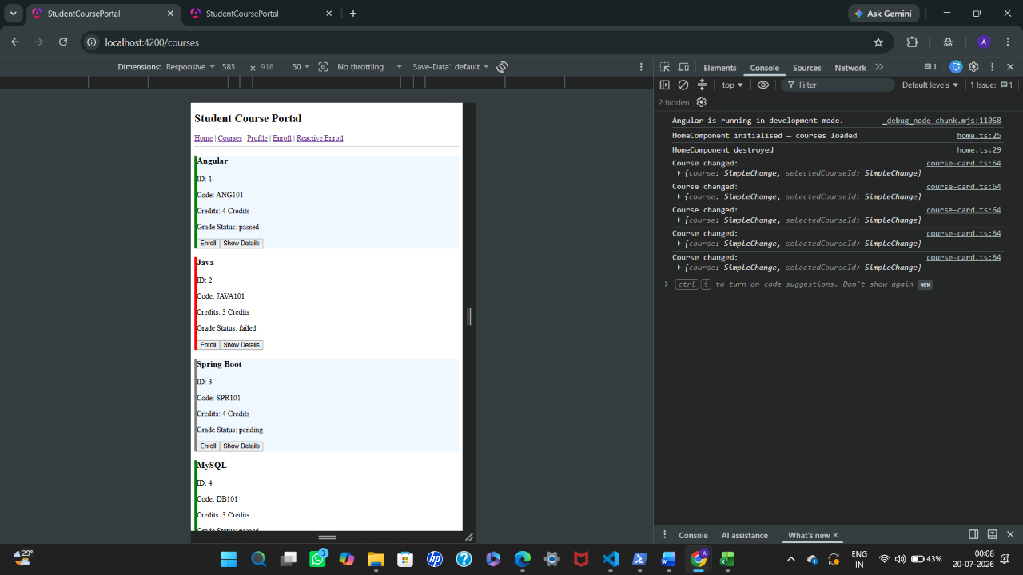
Task 2: Lifecycle Hooks

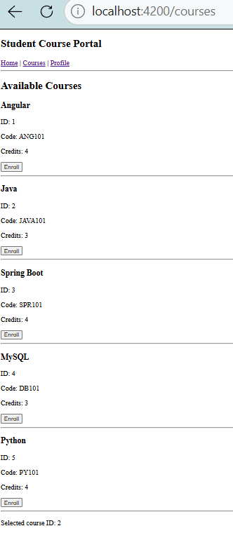
Task 3: @Input and @Output — Parent-Child Communication

Hands-On 3: Directives & Pipes — Built-in and Custom

Task 1: Structural Directives

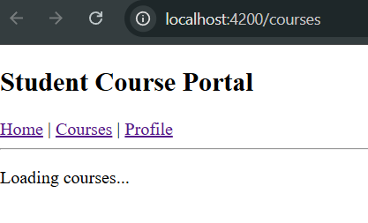

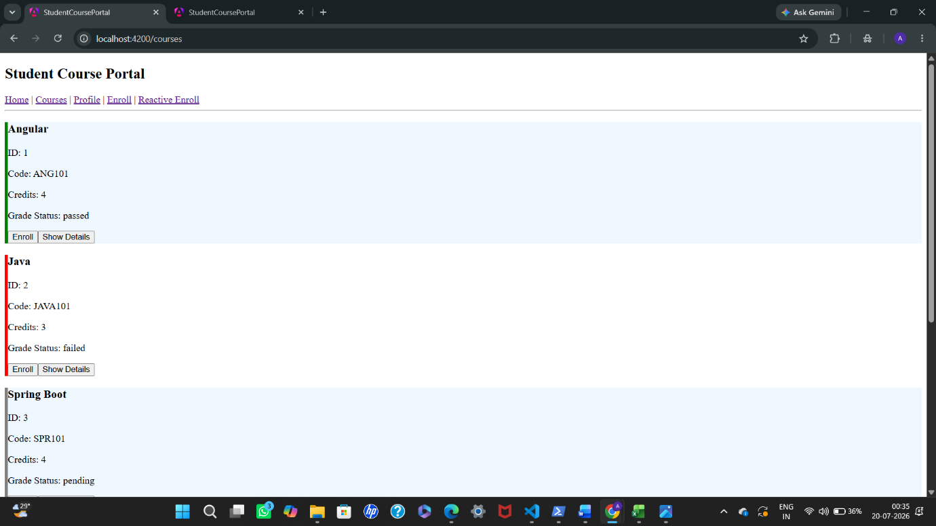
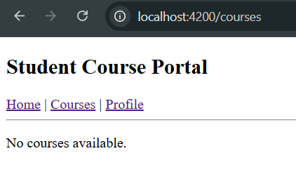
If courses list is empty
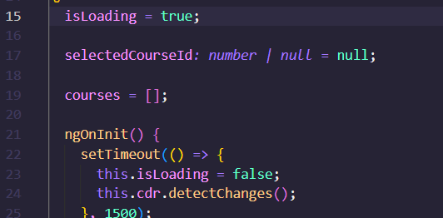

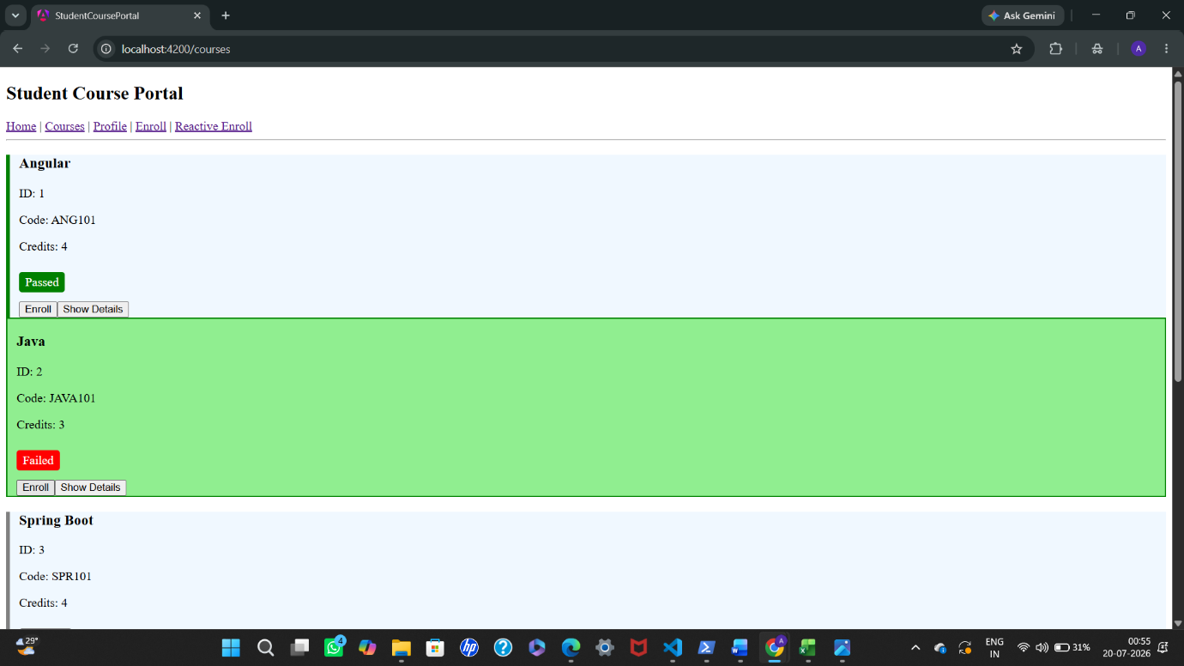
Task 2: Attribute Directives — ngClass and ngStyle
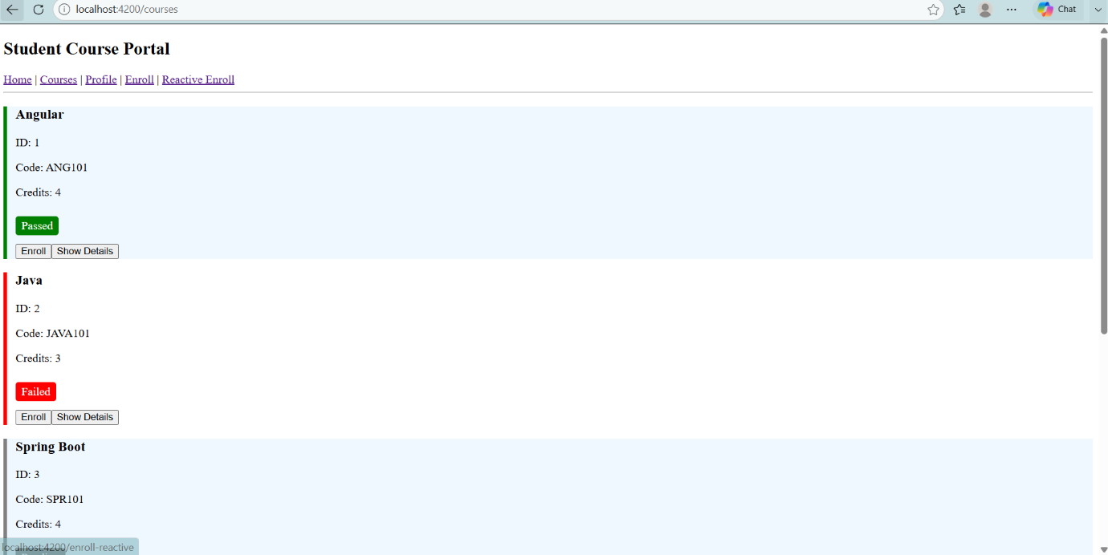

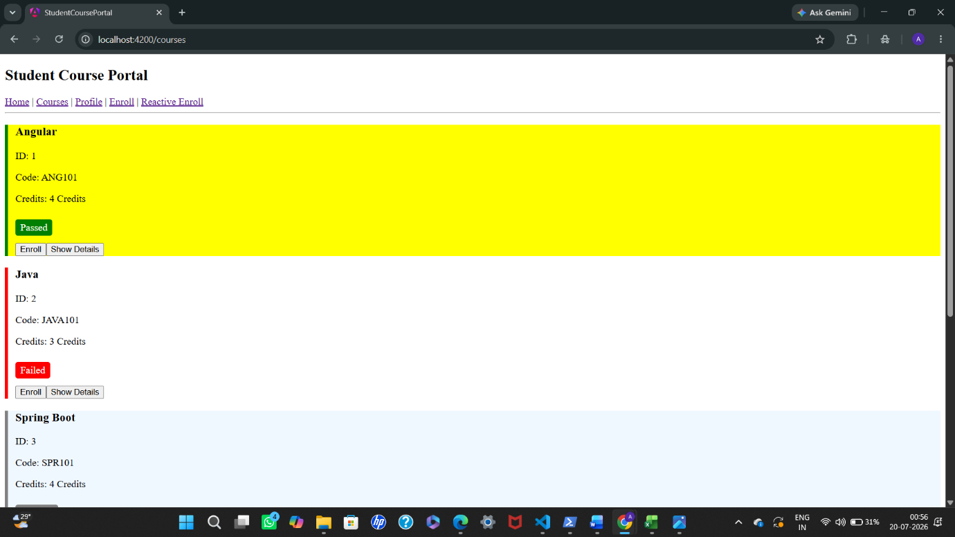
Task 3: Custom Directive and Custom Pipe

Hands-On 4: Template-Driven Forms & Validation

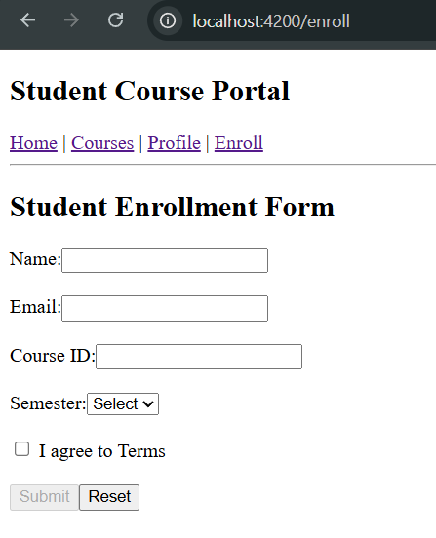
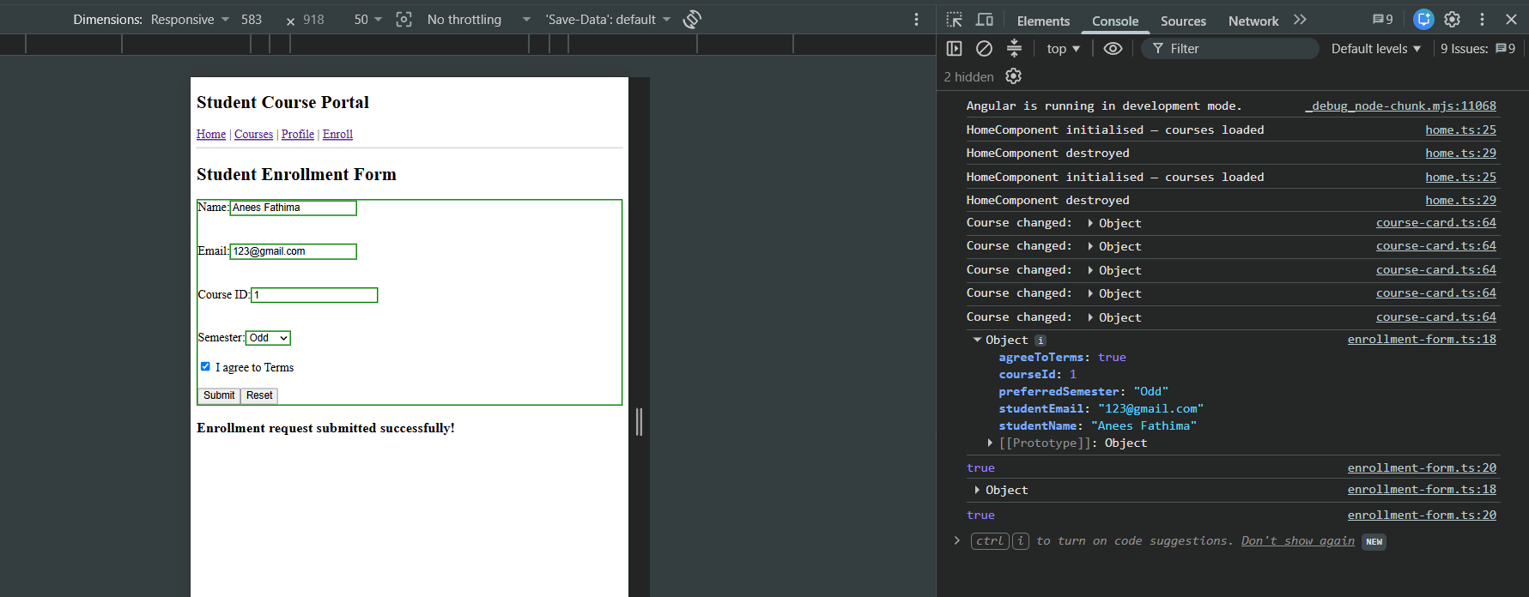
Task 1: Build the Enrollment Request Form

Task 2: Validation and Error Messages
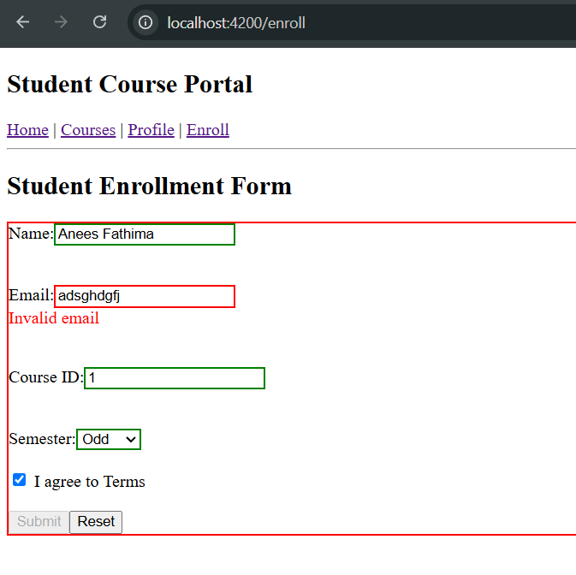
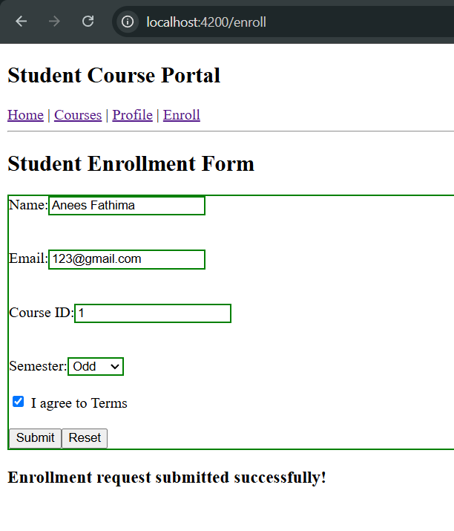
Hands-On 5: Reactive Forms — FormBuilder, FormGroup, FormArray & Custom Validators

Task 1: Build a Reactive Form with FormBuilder
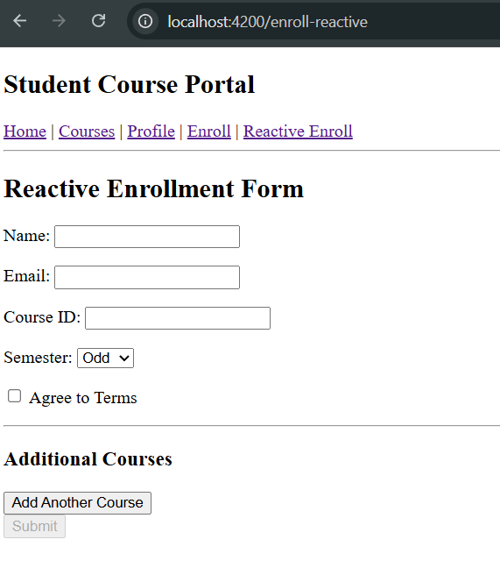
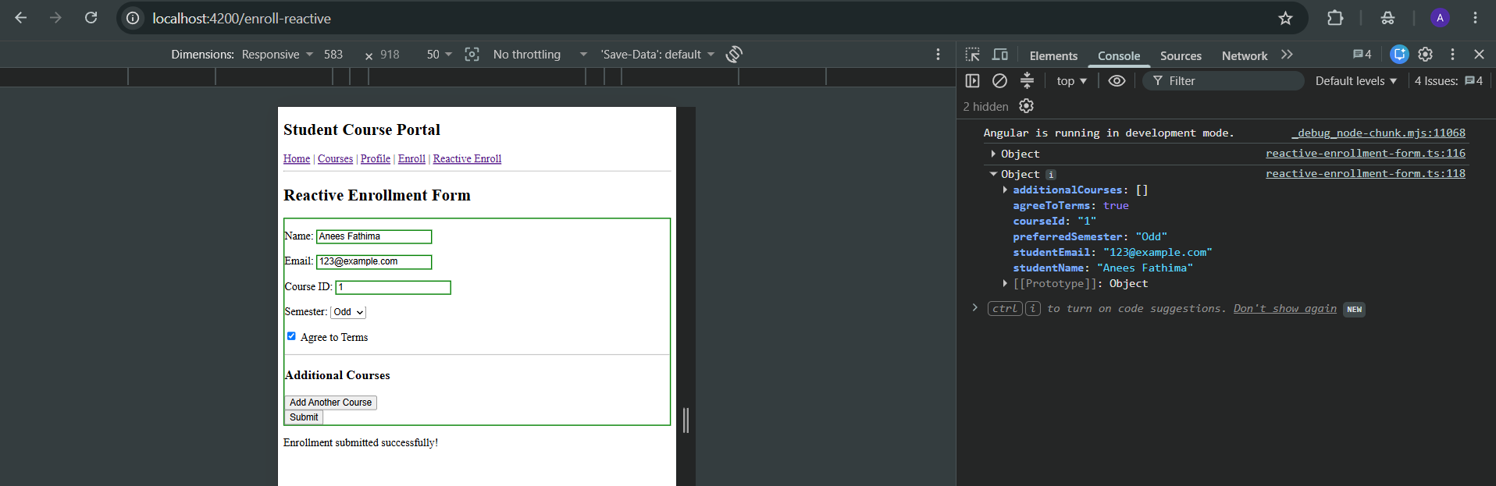
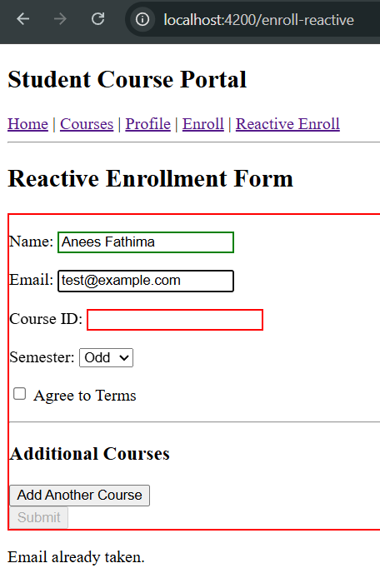
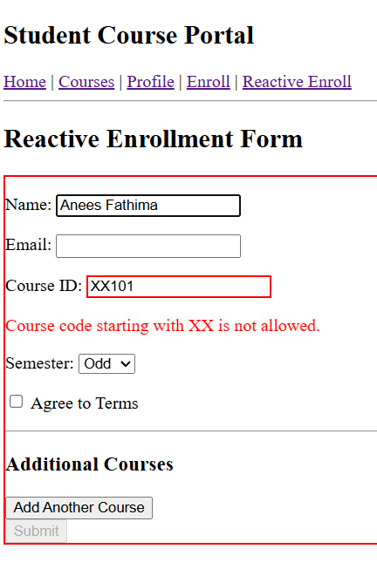
Task 2: Custom Validators and FormArray for Dynamic Controls
